CISC7204 Project Proposal
Analyzing Consumer Purchasing Behavior Using Customer and Shopping Data
Student: QU YING
Student ID: MC641326
Course Code: CISC7204
Course Title: Data Science and Data Visualization
Coursework Item: Assignment 01 – Preliminary Project Proposal

1. Project Topic Name

1.1 Project Title
Analyzing Consumer Purchasing Behavior Using Customer and Shopping Data

1.2 Region
United States

1.3 Domain Category
Consumer Behavior and Retail Analytics

1.4 Research Question
How are customer demographics and shopping behaviors associated with purchase amount in retail transactions?

2. Project Purpose

2.1 Outcomes
The purpose of this project is to investigate consumer purchasing behavior using real-world customer and shopping datasets. The project will examine how customer demographic characteristics and shopping behavior variables are associated with differences in purchase amount.
The project will apply concepts and techniques learned in CISC7204 Data Science Practice, including data importing, data cleaning, exploratory data analysis (EDA), visualization, correlation analysis, predictive modeling, and model evaluation. It also supports my academic and career interests in customer analytics, business analytics, and data science, particularly in understanding customer purchasing decisions through data and using evidence to support business decisions.

2.2 Skills
Through this project, I aim to develop and demonstrate the following data science skills:
- Importing, inspecting, manipulating, and cleaning datasets using Python and Pandas
- Identifying missing values, duplicates, inconsistent data, data types, and other data-quality issues
- Conducting exploratory data analysis (EDA) and descriptive statistical analysis
- Creating and interpreting visualizations using Matplotlib and Seaborn, including scatter plots and boxplots
- Examining relationships between variables using correlation and appropriate statistical techniques
- Exploring suitable predictive modeling and model evaluation methods
- Communicating data-driven findings clearly and reproducibly

2.3 Knowledge
The project will develop knowledge of consumer purchasing behavior, customer demographics, shopping patterns, retail analytics, customer segmentation, and factors associated with consumer spending. It will also strengthen understanding of how statistical and predictive methods can be applied to customer analytics.
An important consideration throughout the project will be distinguishing association from causation. Relationships identified in observational datasets will not automatically be interpreted as causal effects.

3. Project Tasks

3.1 Task 1: Data Collection and Dataset Evaluation
Two publicly available datasets will be considered.
The primary dataset is the Shopping Behaviour Dataset from Kaggle. It contains customer and shopping variables including Gender, Age, Location, Subscription Status, Discount Applied, Previous Purchases, Frequency of Purchases, Category, and Purchase Amount (USD). These variables are directly related to the proposed research question, making the dataset suitable for the initial analysis.
The complementary dataset is Customer Personality Analysis from Kaggle. It contains additional information about customer demographics, income, household characteristics, spending across product categories, web/catalog/store purchases, deal purchases, and campaign responses. This dataset will be evaluated for complementary use based on data quality, variable compatibility, and relevance to the research question.

3.2 Task 2: Data Importing and Preparation
The datasets will be imported and inspected using Python and Pandas. The preparation process will include checking rows, columns, variable names, data types, missing values, duplicate records, inconsistent or invalid values, and variable formats. Relevant variables will be cleaned or transformed when necessary to produce analysis-ready datasets.

3.3 Task 3: Exploratory Data Analysis
EDA will be conducted to understand the characteristics of the datasets and identify potentially meaningful patterns. The analysis will examine purchase amount distributions, customer demographics, previous purchases, subscription status, discount usage, purchase frequency, product categories, numerical relationships, and differences in purchase amount across customer groups.
The specific variables and methods may be refined after examining dataset quality and structure.

3.4 Task 4: Data Visualization
Visualization will be used to investigate relationships and differences in purchasing behavior.
The initial visualizations include:
- A scatter plot of Previous Purchases vs. Purchase Amount (USD)
- A boxplot of Purchase Amount (USD) by Gender
Additional visualizations may be developed based on the results of the exploratory analysis, such as comparisons by subscription status, discount usage, purchase frequency, age group, or product category.

3.5 Task 5: Statistical and Predictive Analysis
Statistical analysis will be used to investigate relationships between customer characteristics, shopping behavior, and purchase amount. Possible methods include correlation analysis, group-based descriptive statistics, appropriate statistical comparisons, and linear regression or another suitable predictive model. Final methods will be selected based on the characteristics and quality of the available data.

3.6 Task 6: Interpretation and Communication
The final project will interpret important patterns, relationships, and group differences in relation to the research question. Results from statistical or predictive analysis will be communicated using clear visualizations and concise explanations. Dataset limitations and the distinction between association and causation will also be discussed.

4. Project Criteria for Success
The project will be considered successful if it meets the following criteria.

4.1 Dataset and Data Preparation
- Relevant publicly available datasets are identified, documented, and appropriately evaluated.
- The primary dataset contains variables relevant to the research question.
- Data structure and quality are properly inspected using Python.
- Missing values, duplicates, inconsistent values, and data types are appropriately examined and handled.
- The data preparation process is reproducible.

4.2 Analysis
- The analysis directly addresses the research question.
- EDA is conducted before drawing conclusions.
- Descriptive statistics and relevant relationships between variables are examined.
- Statistical and/or predictive methods are selected appropriately based on the data.
- Findings are supported by evidence from the datasets.

4.3 Visualization
- Visualizations directly support the research question.
- Appropriate chart types are selected for numerical and categorical variables.
- Figures contain clear titles, labels, and readable scales.
- Visualizations communicate patterns without being misleading.
- At least one scatter plot and one boxplot are included as planned initial visualizations.

4.4 Interpretation and Reproducibility
  - Findings are clearly connected to the research question.
  - Important patterns and relationships are explained using evidence from the data.
  - The analysis distinguishes association from causation.
  - Relevant dataset and analytical limitations are acknowledged.
  - The Jupyter Notebook contains the main Python code used for data importing, preparation, EDA, and visualization so that the main analytical steps can be reproduced.

5. Visualization Justification
Two preliminary visualizations have been created using the primary Shopping Behaviour Dataset.
- Figure 1. Previous Purchases vs. Purchase Amount (USD)
Visualization Type: Scatter Plot
The scatter plot examines whether there is a visible relationship between customers' previous purchases and their current purchase amount. This chart is appropriate because both variables are numerical and it allows possible trends, clusters, or changes in purchase amount to be observed. Correlation analysis provides an additional numerical measure of their linear relationship.
The preliminary visualization does not show an obvious strong linear pattern. However, this does not mean that purchasing behavior has no relationship with purchase amount overall. Other variables, such as age, subscription status, discount usage, purchase frequency, and product category, may provide additional information. Therefore, the final project will consider multiple customer and shopping behavior variables.
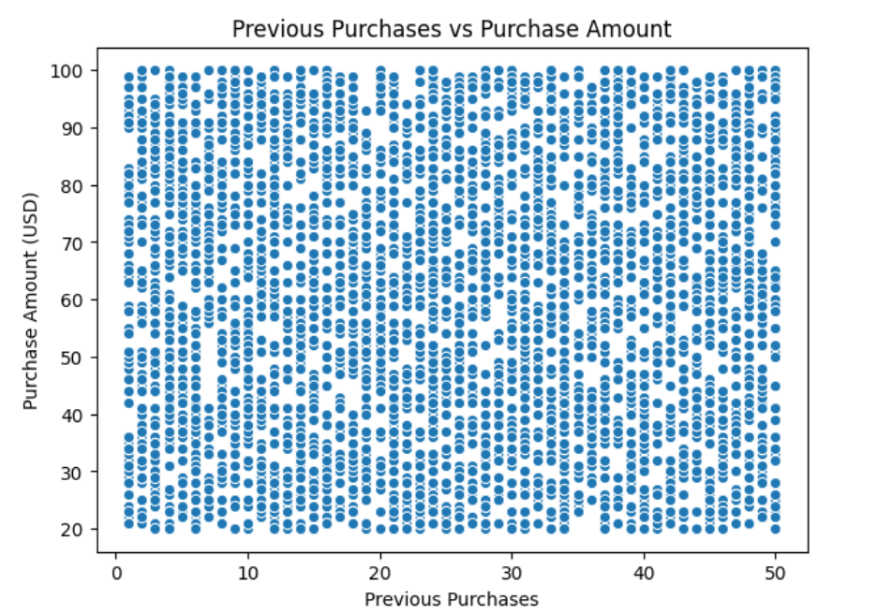
- Figure 2. Purchase Amount (USD) by Gender
Visualization Type: Boxplot
The boxplot compares the distribution of purchase amounts across gender groups. It is appropriate because it shows the median, spread, and potential outliers of purchase amount, allowing group differences to be examined beyond simple average values.
The preliminary boxplot shows broadly similar purchase amount distributions between the gender groups, without a dramatic visual difference. However, gender is only one customer characteristic, so additional demographic and shopping behavior variables will be considered in the final analysis.
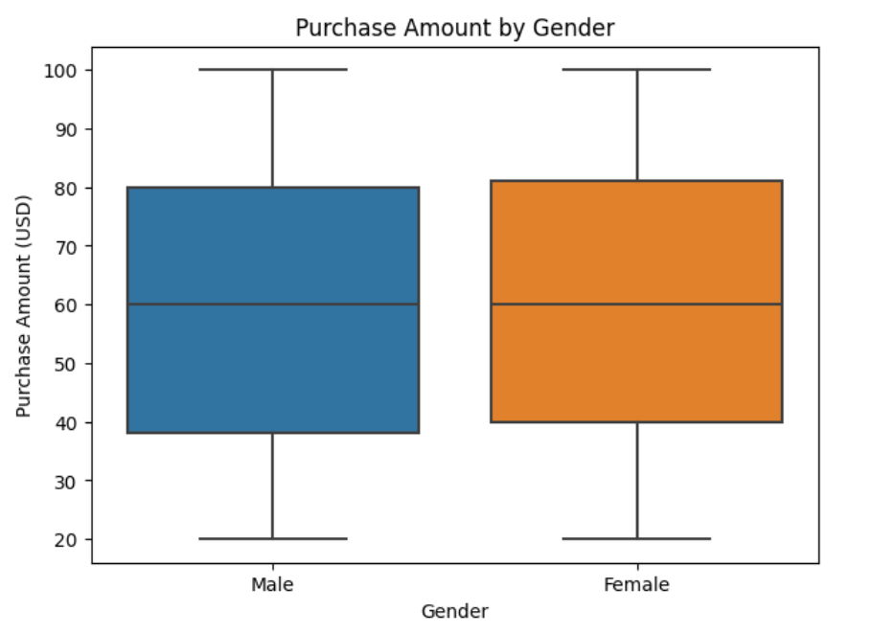
- Overall Visualization Rationale
Together, these visualizations provide both a numerical-variable perspective and a categorical-group perspective on consumer purchasing behavior. The scatter plot examines the relationship between previous purchasing behavior and purchase amount, while the boxplot compares purchase amount distributions between customer groups. Additional visualizations may be developed after further EDA.
These visualizations are intended to identify associations and patterns, rather than demonstrate causal relationships.

6. Data Sources
(1) Primary Dataset
Shopping Behaviour Dataset — Kaggle
The dataset contains customer demographic and shopping behavior variables, including purchase amount, previous purchases, frequency of purchases, subscription status, discount usage, and product category.
- Complementary Dataset
Customer Personality Analysis — Kaggle
The dataset provides additional information about customer demographics, purchasing behavior, spending patterns, household characteristics, and customer responses.
The two datasets will be evaluated based on relevance, data quality, variable compatibility, and their ability to contribute to the research question.

7. Optional Supporting Evidence: Jupyter Notebook
A preliminary Jupyter Notebook has been developed using the primary Shopping Behaviour Dataset to verify the feasibility of the proposed analysis and visualizations.
The Notebook currently demonstrates:
- Dataset importing and initial data inspection
- Preliminary exploratory data analysis
- Scatter plot of Previous Purchases vs. Purchase Amount (USD)
- Boxplot of Purchase Amount (USD) by Gender
- Preliminary correlation analysis
The Notebook is provided as supporting evidence for the proposal, rather than as the final project analysis. The variables, visualizations, statistical methods, and analytical approach may be further developed after the datasets are examined in greater detail.
Project Collaboration: This is an individual project; therefore, team-based collaboration roles and division of work are not applicable.

